PANSY
Origin
Pansies come from the genus Viola, specifically Viola Tricolor, a wildflower from Europe and western Asia of the name heartsease. So technically, all Pansies are a type of Viola, but not all Violas are Pansies. Pansies can come in what is referred to as a “Clear Faced Flower” or a “Faced Flower”. The pansies with faces are also referred to as being “blotched” or having an “eye”. Their blooms consist of four petals pointing up and one petal pointing down. Violas on the other hand, have three petals up and two down. Violas, in general, also have smaller blooms than pansies.
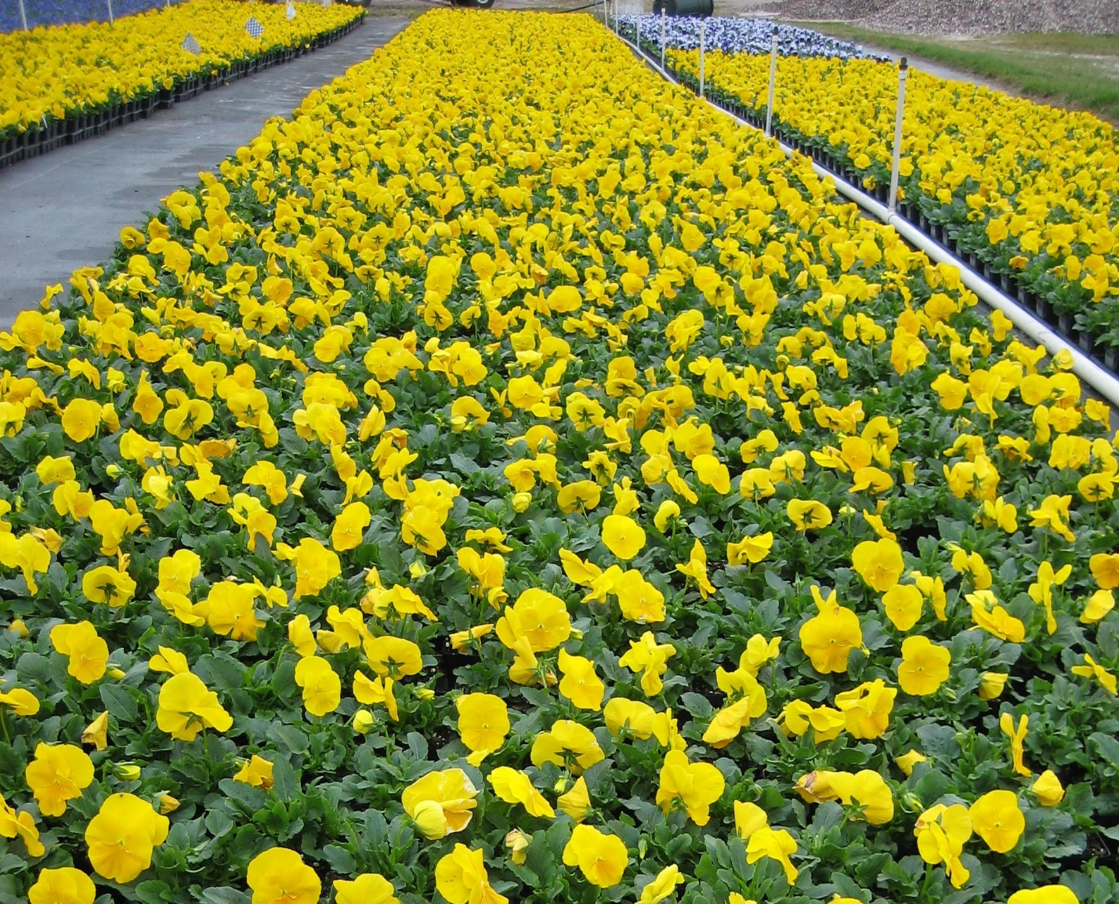
The name Pansy comes from the French word pensée meaning “thought”. In the late 1700s and early 1800s there was a lot of cultivating of the pansy throughout Europe, and by 1833 there were over 400 varieties of Pansy available to gardeners.

In the Landscape
Pansies are one of the most sought-after winter flowers for good reason. If placed in the right location, pansies are a maintenance free option in the landscape. They are extremely cold tolerant. They can be completely covered by snow or ice and not be damaged. They need to be in full sun and do not like to stay wet. Violas can take more shade than pansies, so if you are questioning the amount of sun in an area, violas might be a better choice. They will last as long as the conditions stay cool and dry, but will decline quickly in wet/warm conditions. Pansies should never be over watered as this will absolutely result in the plant rotting and dying. Foggy or misty conditions will cause botrytis, which will make the blooms decline, but will not damage the plant. The blooms will get covered with a “fuzzy” appearance of spores, and the blooms will collapse. You can treat for botrytis with chemicals, but a few sunny days will correct the problem just the same.
On the Table
Pansy blooms have been used for food for as long as they have been admired in the garden. Their blooms are used fresh in salads and as decorations on cakes. Their blooms are also candied and used in desserts. Eaten fresh, they have a lettuce like flavor that might be slightly spicy. NEVER eat any flowers from a nursery unless you have been told they have never been treated with any chemicals.
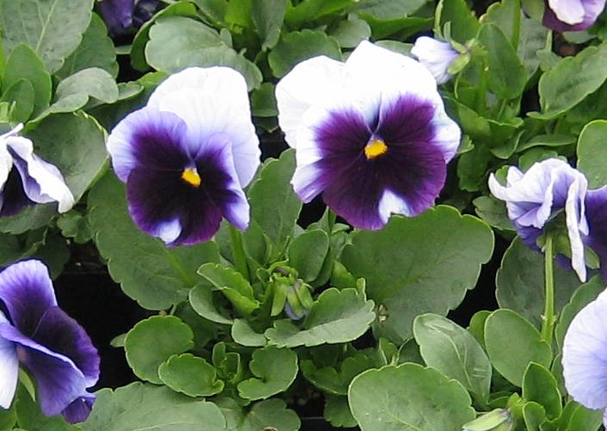
Fun History
Pansies have a rich history and were even used at King Arthur’s Knights of the Round Table. The knights would pluck a petal from the flower and read the petal to determine their future. If the petal had four lines, it meant there was hope for the knight. If the lines leaned left, there was trouble ahead. If the lines leaned right, the knight would have prosperity and a long life.
Legend says that pansies were always white until Cupid shot his arrow through a pansy bloom. At that point, pansies started having yellow and purple colors in their blooms. This is also where the pansy got the reputation for being an ingredient for love potions.
You can see pansies everywhere. They are used as city and state flowers, logos for companies and organizations, and many people remember the famous scene in Alice and Wonderland with the singing pansies.
So next time you want a bright option for a sunny and dry location, use the pansy to add a splash of color to your landscape!

